On the Odic force

By Adérito J.E. Machado

An initial note
Before reading this thought, I would like to inform the reader that this is what it is: just a thought. I would like for this text to just be food for thought, a mere source of information for the creation of possible hypothesis by the readers and ITC experimenters. However, it is not based on thin air. It actually emerged from the intersected information of my personal beyond-normal experiences. I can share some succinct documents where I describe the most relevant ones if the reader wishes to access them. My e-mail can be found at the end of this document on “Final remark”.

The force of Od

The definition is not rocket science, actually. The force of Od, or Odic force, is a hypothetical form of vital energy or life force described by Baron Carl von Reichenbach. The name comes from (as the reader might have guessed) “Odin”, the norse god. Although it’s possible to find the book about the Od force on the internet easily and legally, written by the referred author, I still haven’t read it at the time of this writing. However, I would like to take this as a first trial as part of a possible collection of future thoughts and thought experiments. Despite not having read the book, I think I have enough background to state what I’m about to present.
According to what one may find on Anabela Cardoso’s book, “Electronic Contact with the Dead: What do the Voices tell us?”, on page 25, the Luxembourg group received communications from Timestream station regarding the form of energy that they use. They answered “We work with Orgone energy (…)”. In the same page, it is also referred that Adolf Homes received information regarding the mysterious form of energy used by the deceased, although with the name “Od energy”, supposedly similar to Reich’s Orgone energy, Chi or Prana. I will now proceed to describe my thought.

The Gatelink Generator

Why Gatelink? It’s just a fancy term that I came up with and is derived from “gate” and “link”. After all, coining terms is something that everyone has made throughout history. However, it also has a meaning like any other term. The Gatelink is “a complex, synergistic system of several forms of energy designed to increase the force of Od and in a designated place”. Maybe the energy used by the deceased has an “ethereal” nature and arises from interactions that obey the Natural Law. It is “symbolic” in a sense and acts, flows and grows according to interactions between elements and geometry that are in accordance with natural patterns that are a consequence of our physical laws and symbols used throughout history which somehow gained power over consciousness thanks to their constant usage. For example, having a small copper astrological Earth symbol crossed by an electric current with the right intensity could potentially have an effect on the Od energy of a designated space. Now, if one introduces even more elements, such as geometric, material structures and ancient symbols, in such a way that they all exhibit patterns from the Natural Law, the net, synergistic effect grants a greater pool of Od energy. If one uses several elements in a Gatelink Generator, the interconnections between elements make a web that is much more than the isolated parts. For each one element “connected” to another, one has a link which, in turn, is an element. Two base elements can have one connection, which brings a total of three maximum elements. Three base elements can have three connections, which brings a total of six maximum elements. Four base elements brings ten. The number grows and grows non-linearly as the base number of elements increases. Summing it up, the Gatelink Generator is a grand display of artistic, mystical and symbolic meaning which calibrates an environment to act as a point in space-time where the “consciousness firewall” can open. I also have to question the utility of the so called “orgonites”. If these structures act as Orgone energy producers, than the work is half-way done. One only needs to make a structure to store it for further usage.

What is it for?

It’s very interesting to know that the deceased use everyone and everything’s help to convey messages to us, according to some communications referred on Anabela Cardoso’s books. If we are to reinforce communication, the best thing we can do is maybe to give it a try and make literal use of the communications. Using both the power of the machine, nature and the mystical to make a structure that a videogame fan would designate as “magitek” technology is perhaps the path to follow. I used to play videogames a lot, but interests change with age and now I look back and see that maybe there’s more to the stories I knew than meets the eye. Imagine a big area, as big as Figure 1 and Figure 2 present, being used by genuine mediums, ITC experimenters, other researchers from other fields and several elements of nature and technology to put an end to unnecessary suffering; a place where people from around the world could come to talk with their deceased loved ones in order to ease their pain and make suffering more meaningful, since it cannot be avoided and has all the meaning. People would have a more straight-forward idea about how and why they should suffer in a certain way and what would be the best way to bring forth more joy and wonder to their surrounding communities. After receiving a message from a deceased loved one, I can assure the reader that one’s perspective on suffering changes completely.
Sacred places, such as the one presented in both figures, may play a crucial role. I would like to make reference to a presentation given by doctor Rober Schoch available on Youtube, “Dr Robert Schoch ~ The Human and Cosmic Psyche ~ 008” on Ancient Mysteries channel, in which after 8:15 he refers that people are having powerful, beyond normal experiences on the sites he’s studying. It seems that many portions of these sites, holding supposedly sacred symbols, have geomagnetic anomalies and seem to affect people’s consciousness. The question remains if it’s the symbol that creates the anomaly or if it was there already. I think the latter is more plausible, but one has to consider the symbol’s impact. I can say for myself that I had a powerful experience on Our Lady of the Rock’s sanctuary, presented on Figures 1 and 2. There is a great change, a fundamental rewriting of the history of civilisation going on, but that is an issue for another thought. I can, however, advise the reader to search for “Gobekli Tepe”. It’s very interesting. But why do these kind of sites have anomalies? Maybe it’s related to Od force. The symbolic, sacred representations used by our ancestors might have a real effect over the Od force.
And why should we increase Od energy? The answer lies on energy minimization. By increasing Od energy in our realm, the physical plane, the deceased might be able to use it and minimize their energy consumption on the other side. Let us not forget that even mystical energy can be used by them, meaning that maybe ancient traditions can play a role on this type of generator (Gatelink Generator). Furthermore, we should try to literally use complexity, for if we take into account mediumship contacts, then it makes sense to make an analogous of the human brain, through diversity and complexity, which is in accordance with the Gatelink Generator’s nature.

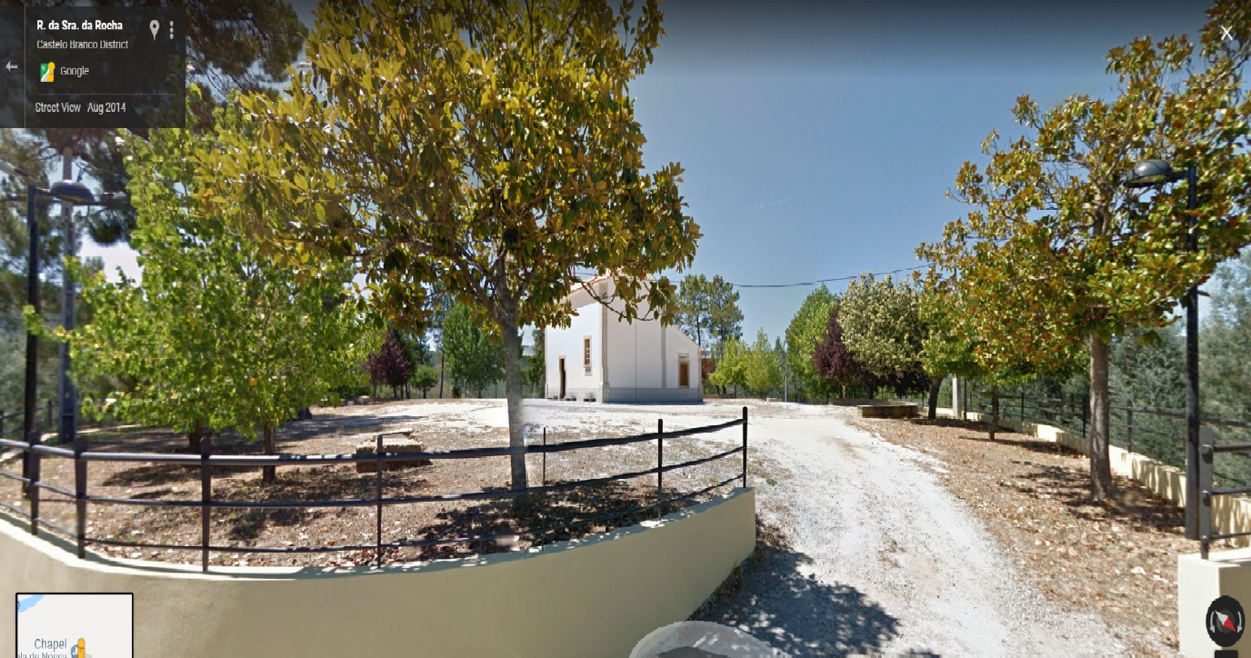
Figure 1: Street View image from Nossa Senhora da Rocha (trans.: Our Lady of the Rock) in Barroca, Fundão, Portugal

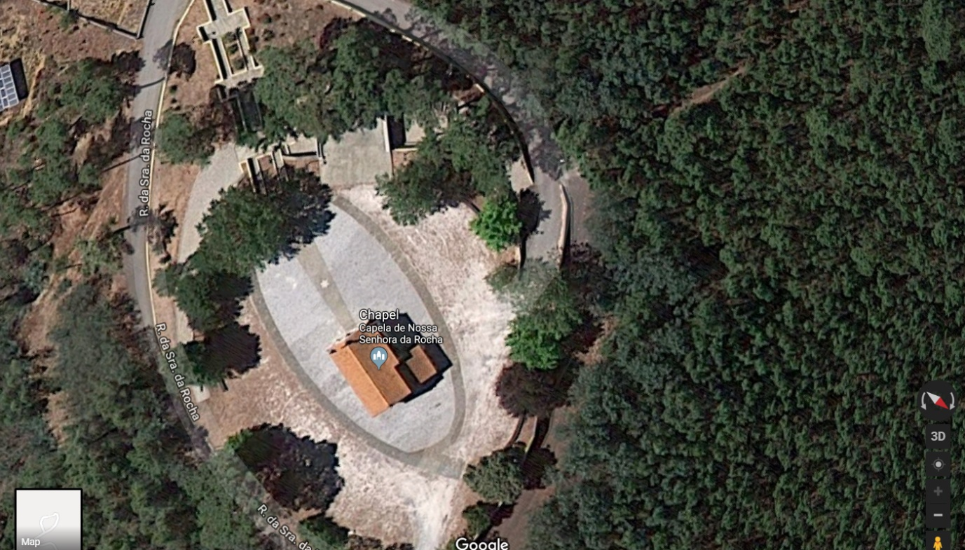
Figure 2: Google Maps image from Nossa Senhora da Rocha in Barroca, Fundão, Portugal (top view)

What about ITC?

It’s actually simple. We could make the Gatelink Generator as a construction around a central receiver system; an antenna-like technological structure that uses both electricity, sound, light, heat and chemical energy (in a basic form, of course) and even quantum vacuum fluctuations (in a more advanced stage) to act as substrates to the messages. This system would need to be as isolated as possible from the outside, with its own “noise generators” inside. Then, the information would be integrated by a single, computational unit, capable of learning in order to minimize even further the energy required and the voice would come out synthesized as close as possible to the one of the deceased that tried to convey a message. Even if the voice sounded robotic, in time and as more data was collected, a profile for a certain deceased’s voice could be made and the computational unit would adapt to the deceased’s needs. Nowadays, neuromorphic chips are a reality and I guess they could play a major role on ITC. One could imagine, for example, integrating neuromorphic chips with several tiny antennas calibrated to well defined thresholds on the SW (short wave) region and capable of detecting “outliers” in the noise within said thresholds. Groups of artificial neurons would be assigned with defined, small thresholds and would detect irregularities. They could save these irregularities and establish which were more prominent, lowering the amplitude of the electromagnetic energy required for them to fire and acting as vassals to the influence of the deceased. This could maybe (and this is a big maybe) be the way to make a stable communication gate, the one that needs to be engineered to finally prove human consciousness and end the philosophical debate over this topic.
Also, there’s another issue: from our point of view, it’s easier to have more people helping with one job than one doing everything alone. If this holds true for the deceased, then each deceased would be assigned to an antenna. This would dramatically lower the energy used by the “main deceased”, that is, the one trying to convey a message. I call this “working as a Pluriscience”. Pluriscience means “plural consciousness” or, in other words, a “consciousness” that arises from several deceased working together.
But how would we know that everything was in its rightful place and that we weren’t making any mistakes? That’s where the role of mediums comes up. Yes, we should strive to perfect ITC, but for now our best bet is maybe to assemble a study group composed of some genuine mediums that can convey messages. Due to the noisy and incoherent nature of the human brain (which has to act as a vassal for both messages and consciousness), one should expect the messages to be unclear sometimes. That is where ITC comes up: it would act as a tool to correct and interpret more correctly the messages captured by the mediums. As the reader may have guessed, we would have an interplay between mediums and ITC experimenters. It would maybe come in handy to find people who could perform remote viewing, if such a psi phenomenon is valid, since sometimes, according to Russel Targ’s “Miracles of Mind”, remote viewers can see into the near future. What I am stating is exactly that maybe we could tap into the many, infinite possibilities of the future and actually make something that I find intriguing: knowledge acceleration. In physical and earthly terms, knowledge acceleration already occurs according to the “law of accelerating returns”, postulated by futurist Ray Kurzweil. However, knowledge is still built on itself and from itself in order to grow. If one could tap into the many possibilities of the future and capture the most probable events regarding future knowledge, we would be able to bring forth the knowledge from fifty years from now into the present time, exaggeratedly speaking. This has profound implications which I don’t wish to debate right now, so I humbly ask for the reader’s understanding.

Virtual particles and non-locality

The increase in Od energy comes therefore from connection, as the reader might have already guessed and if my thought is correct. But it needs to be stored, somehow. Also, I have a feeling that if it’s not stored or spent, it might have the same effect as an out-of-control reactor. Furthermore, if by ANY chance the deceased use virtual particles to communicate that would explain a lot about the difficulty to do so. Creating a pair of virtual particles haphazardly might have a not-so-positive effect on our world. Virtual particles would also explain how they can interact with electricity and light and interfere with radios and electronic devices. The role of noise would also become self-evident: minimizing negative effects on our plane of existence. That is why micro and nano-systems are maybe the best choice to go even further on ITC, since they can be more easily manipulated without macroscopic repercussions, if this virtual particles’ hypothesis is true.
There is also the matter of non-locality. If consciousness is non-local, that would explain why sometimes it’s better for the deceased to interact with the electromagnetic radiation coming towards a radio a meter away from it and sometimes two or three. Maybe the noise a meter away is better at a certain instant; maybe the noise coming from the corner of the room is better; maybe the noise going through the radio at 6:47 pm is better… who knows? However, there is certainly something really neat that we can do to aid on communication, even if our deceased loved ones state that communications depend mostly on them. One of the “keys” is most certainly open-mindedness and that is something which is growing at a progressively faster rate, almost exponentially. Another is what I’ve already stated: increase the force of Od. Century of neurosciences? I believe this is more the century of consciousness.

Final remark

Don’t take the things I said too seriously. This is just a thought, as I explained earlier. But in case the reader is willing to know about my experiences, my e-mail is aderitomachado33mail.com. It’s with great pleasure and humility that I have written this text and I hope that somehow it will be used as food for thought in the future. If we all consider many possibilities together, the reality of ITC will certainly become a better one in the future. One of these days, I should be able to discourse about the nature of symbolic representation and how we can reproduce artificially certain “frequencies” attributed to certain cosmic phenomena. I would like to thank doctor Anabela Cardoso for her dedication to the field of ITC and her friendship and to you, dear reader, for reading this thought.

I dedicate this thought to my sister and my friend Diogo, who is no longer among us physically.

Hands up high, Oh warriors of Light
And carry on a thousand times, forever lasting ride
Land of Light, the glorious unite
Oasis for a thousand lives, forever we survive

Freedom Call – Warriors of Light

